**ĐẠI HỌC QUỐC GIA TP.HỒ CHÍ MINH**

**TRƯỜNG ĐẠI HỌC BÁCH KHOA**



**KHOA KHOA HỌC VÀ KỸ THUẬT MÁY TÍNH**

**BÁO CÁO**

**LAB 3 : SYNCHRONIZATION**

**GIẢNG VIÊN HƯỚNG DẪN: BÙI XUÂN GIANG**

**SINH VIÊN THỰC HIỆN: NGUYỄN TẤN PHÁT**

**MSSV: 2352888**

**LỚP: CN01**

**Thành phố Hồ Chí Minh – 2025**

**PROBLEM 1**

**Code:**

**Output:**

**PROBLEM 2**

**Code:**

**Output:**

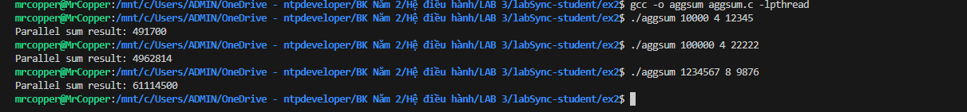

**PROBLEM 3**

**Code:**

**Output:**

**PROBLEM 4**

**Code:**

**Output:**

**PROBLEM 5**

**Code:**

**Output:**

**PROBLEM 6**

**Code:**

**Output:**

**PROBLEM 7**

**Code:**

**Output:**

